Sprint 0 – Requirements
Log in Page requirements:
2 options: “Sign in” & “Create new”
  - Gives user the option to sign in with an existing account or sign up with a new account
- Sign in:
  - 2 textboxes – Email and password AND a “Sign in” button
    - OPTIONAL – If user forgot email or password, user should be provided with the choice to send confirmation of change (if password or email is changed) to their phone number via SMS
    - OPTIONAL – Alternate sign in with phone number – Email textbox can then be “Email or Phone” textbox
  - At the bottom of the sign in page should be a small bit of text with a link to “Create New”
  - If correct email and password, user will be loaded/accepted into the team page
  - If email or password or both is incorrect, it should be communicated to the user in a clear way:
    - Eg. Email is incorrect – a pop up should appear stating that “Email is incorrect”
  - If incorrect email or password was entered: prompt user to change/forgot password
    - From here, the user should be provided an option to enter their email, and enter a new password. To confirm this new password, the user should log into their email, and click “Verify”.
- Create New
  - 4 textboxes – Name, email, password, password confirmation AND a “Create Account” button
    - OPTIONAL – a 5th textbox with phone number
  - At the bottom of the sign in page should be a small bit of text with a link to “Sign in”
  - Password:
    - Password should have a minimum character limit of 6, one upper case letter, one lower case letter, one symbol, one number – Deploy at least 2 of these features.
      - If password is too weak (does not meet the 2 conditions, communicate to user that they need a stronger password)
  - To confirm account creation, the a verification email must be sent to the user’s email address upon creation which is when user clicks “Create account”
    - User must click on the verification email and verify to successfully create the account
    - OPTIONAL – Alternatively, if user provided a phone number, the user can select phone number (SMS) as the means of verification of account creation as well.
  - If log in details are all valid, a pop up should appear with “Account created successfully”, and user should be re-directed to the “Sign in” page
    - Here, they will sign in with their newly created account

Team Page requirements:
Goal of the Team page: A short “About us” to introduce the team, and the project that will be developed.
5 Requirements:
- Project Name (follow the teams chat name) – This will be the headline of the team page
- “Automated Testing Framework for Body Worn Camera Integration with PSCore — Team A”
- This will essentially the <h2> or Subheading – The title <h1> will be “The Team”
- Summary/brief description of what the project entails – Consolidate the meeting minutes from last week (4/8) and this week (11/8)
- This should briefly introduce and describe the end goal fo what we are trying to develop; a series of scripts to initate a connection automatically with a Motorola camera through a phone using the PSCores app – Check this against the Meeting notes thus far
- Group Member names
- Group member profile picture (As no member has submitted a formal picture, use a default placeholder for this one similar to instagram or teams.)
- Group member’s skills and background – Located at the top of our team's chat in tabular format
2-5 CAN BE DONE AS A SINGLE TABLE
- This page will be static – Meaning it won’t have much interaction or links to rotate into other tabs

UX wireframes
Wireframes were created based on the BA requirements for the following pages:
Login Pages
- Sign In
- Create New Account
- Forgot Password
The wireframes include the required input fields, buttons, password requirements, password reset option, and navigation between the login pages.

Team Page
The Team page wireframe includes:
- Project title
- About the Project section
- Five team member profiles
- Profile picture placeholders
- Member names
- Skills
- Background
All wireframes follow a consistent layout and visual style.

Wireframes
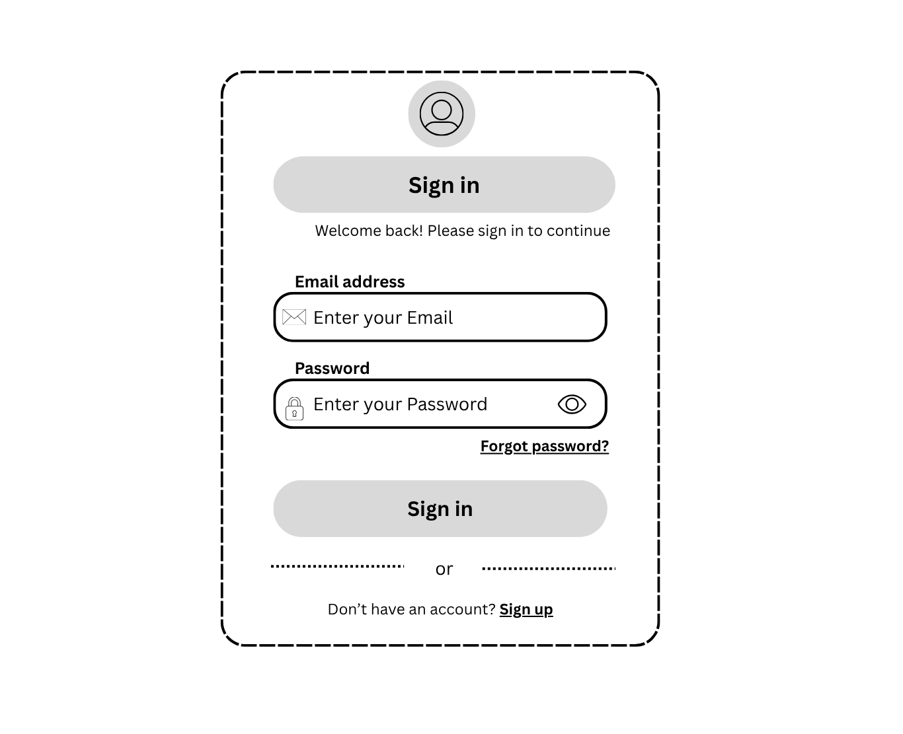
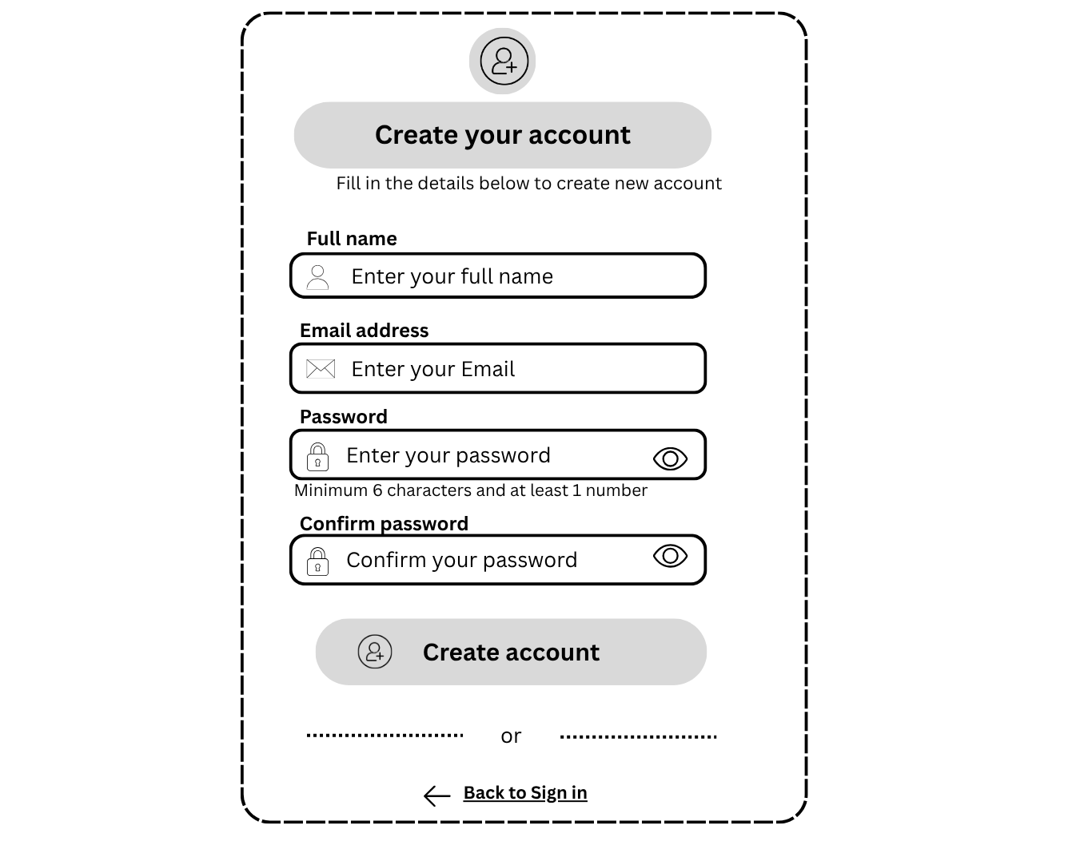aaaaaaaaaaaaa
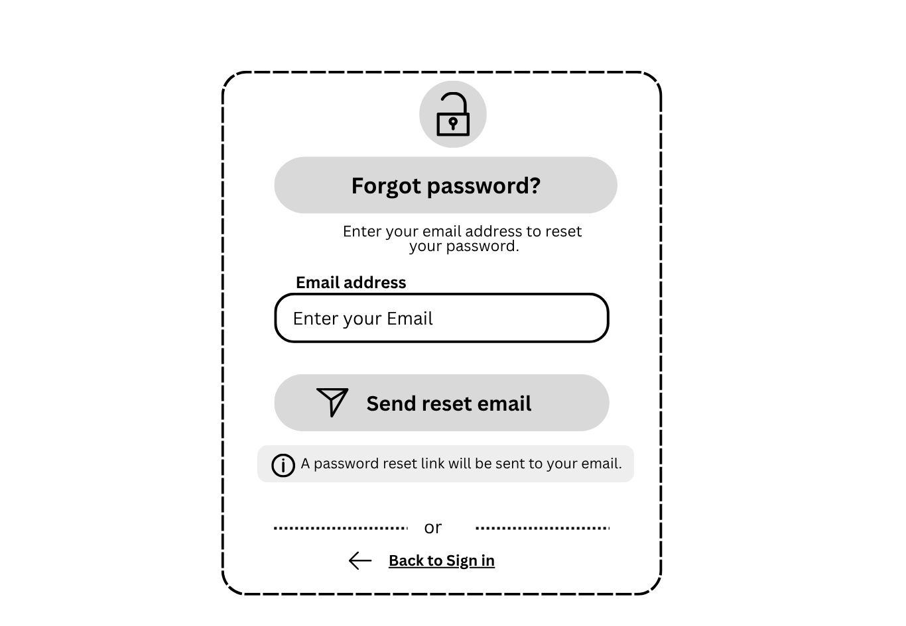
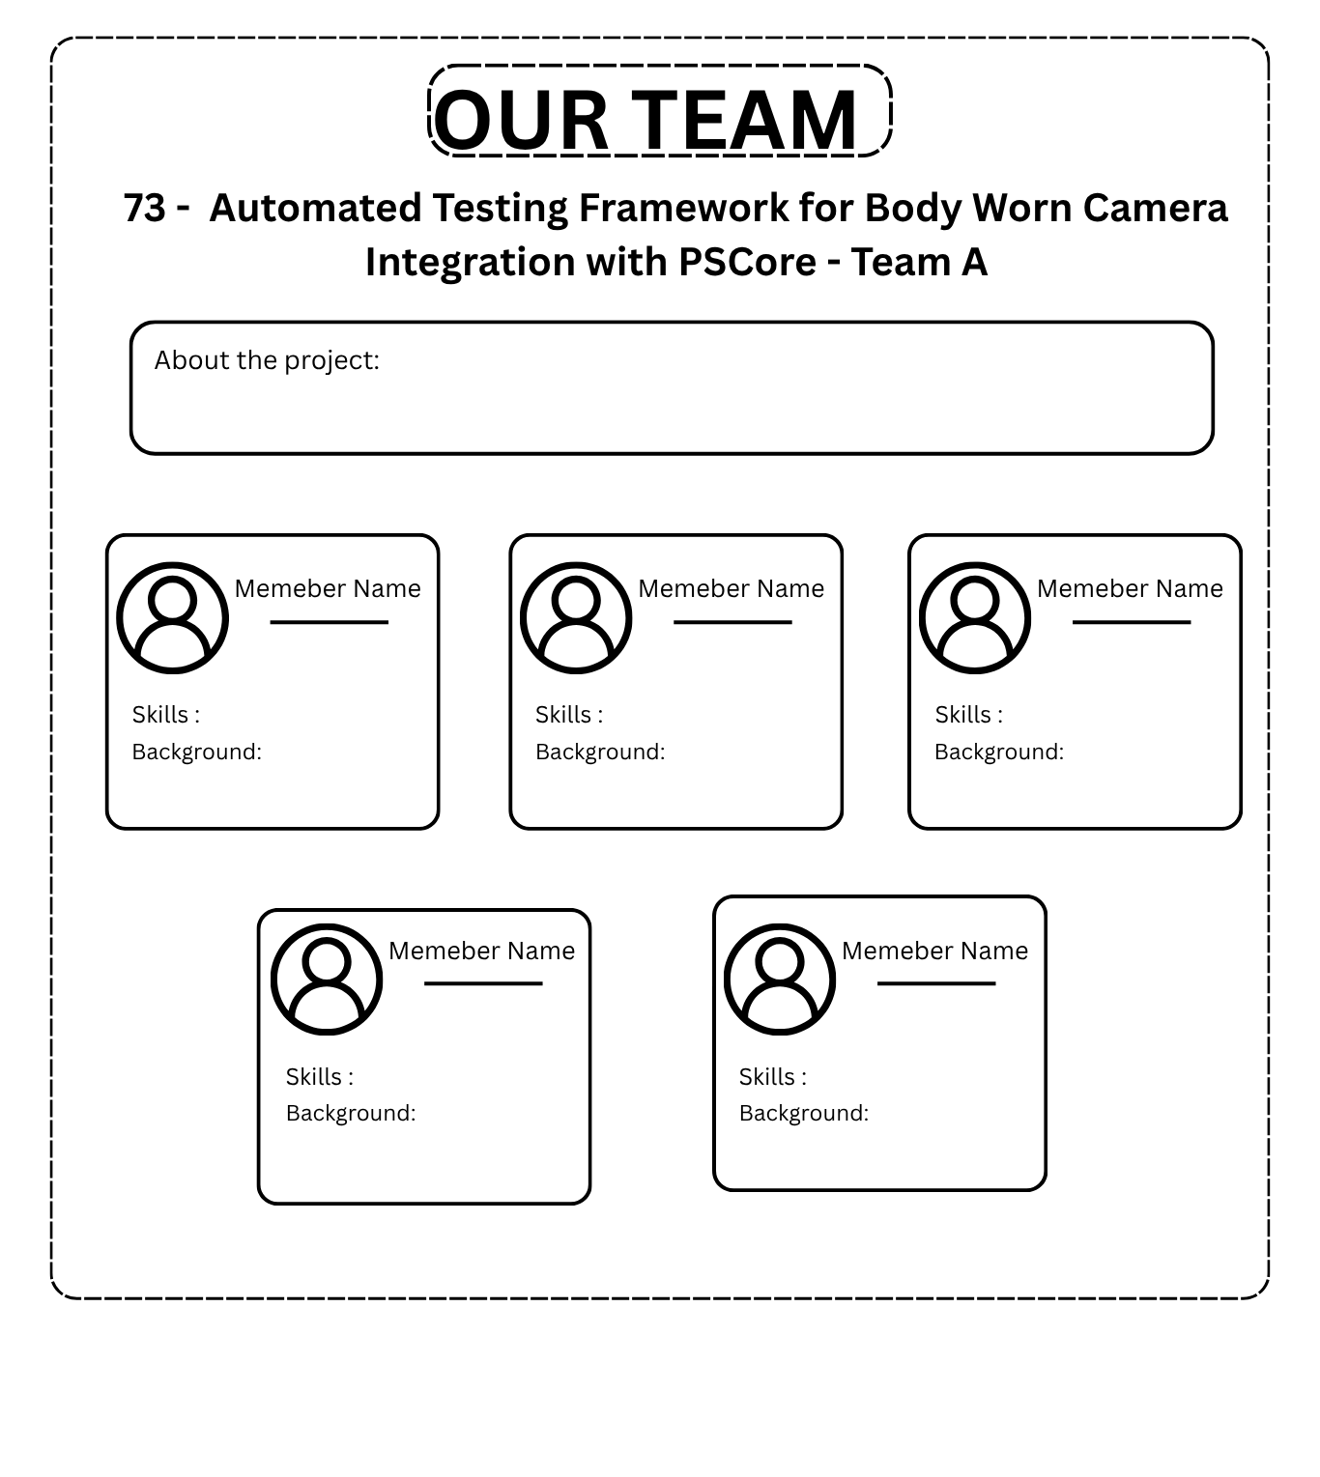

Wireframe Validation:
Login Page:
Overall, meets every requirement.
Team page:
Overall, meets every requirement. One main concern, more towards the devs:
Each member has a different amount of detail regarding their skills and background, will the size/amount of text have to be cut down in order to maintain a good presentation for the members textboxes? Perhaps, add a “read more” feature in the boxes. This will ensure that the 5 textboxes for each team member are the same size until the user clicks “read more” where the textbox will then expand.

